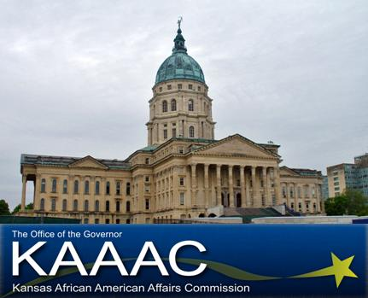 | African American Youth Day: Quest for the Best!  Topeka, Kansas  March 22, 2011  Completed applications due by March 11  Helpful Facts & Schedule of Events

Helpful Facts

Who can participate in African American Youth Day?
Young people ages 9-20 throughout the State of Kansas who want to discover their leadership skills.

What will happen at the Event?
We will....
- Bring together young people to share information with each other. Topics such as leadership, goal setting, assertiveness, disability awareness, advocacy, cultural heritage, and much more.
- Involve numerous presenters, such as community leaders, legislators and other professionals who will interact with the students.
- Identify existing barriers to personal and professional success and develop plans to deal effectively with those barriers.
- Assist in developing a “Personal Leadership Plan” which will include specific action plans for the students when they return to their communities.
- Participate in activities such as: small group discussions with fellow students, large group presentations by successful community leaders, a luncheon with community mentors, and a picture at the State Capitol.

What is involved in the application process?
Student applicants must mail the completed application packet to the KAAAC office no later than March 11. Selected applicants will be notified by letter, with detailed information regarding the Forum. Approximately 30-40 youth will be accepted to attend.

Cost:
Except for $5 for the cost of the lunch, there will be NO charge for student delegates or volunteers to participate in this leadership event. All appropriate expenses will be paid by KAAAC including interpreters for deaf students, personal care attendants, and other accommodations, as needed.

Transportation:
Parents or guardians must provide transportation for their students to and from events.

Schedule of Events

Legislative Pages:
Pages, ages 9-12, will be connected with their area State legislature and shadow them for the day. This will give them an in depth view into the political process and how they can become engaged at a young age.

Tentative Page schedule:

7: 00 am – Arrive at Kansas African American Affairs Commission
- Doughnut and juice provided
- Introduction and Orientation Break-out Session

8:00 am – Report to Capitol building
- Meet representative
- Begin shadowing process

12:00 – 1:50 – Lunch and Awards Ceremony

2: 00pm Capitol Tour

3: 00 Brown v. Board Museum

Junior Delegates:
Junior delegates, ages 13 – 16, will host a community service project in collaboration with State Legislatures and the Corporation for National and Community Service. This will give them an in depth view into the importance of civic engagement and how they can give back to the community.

Tentative Junior Delegate schedule:

7: 00 am – Arrive at Kansas African American Affairs Commission.
- Doughnut and juice provided
- Introduction and Orientation Break-out Session

8: 00 am – 11: 30 – Community Service Project

12:00 – 1:50 – Lunch and Awards Ceremony

2: 00pm Capitol Tour

3: 00 Brown v. Board Museum

Senior Delegates:
Senior delegates, ages 17-20, will create a strategic plan of African American youth involvement pertaining to issues they feel effect their communities. They will then present this plan to the Kansas African American Affairs Commission and brainstorm ideas of implementation. The senior delegate with the strongest application will be offered an internship with the Kansas African American Affairs Commission.

Tentative Senior Delegate schedule:

7: 00 am – Arrive at Kansas African American Affairs Commission.
- Doughnut and juice provided
- Introduction and Orientation Break-out Session

8:00 am – Develop strategic plan: African American Youth Leadership: The next 150 years

10:00 am – Present plan and implementation to KAAAC Commission

11:00 am – Capitol Tour

12:00 – 1:50 – Lunch and Awards Ceremony

2:00 Brown V. Board Museum

For additional information, please contact the KAAAC office
at 785.296.4874 or email: shawn.bryant@ks.gov
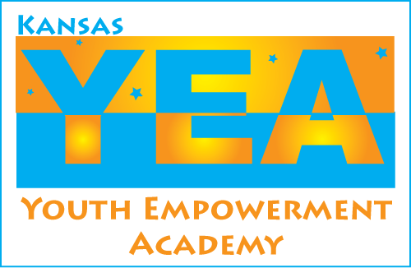
Fact sheet format used with permission from the Kansas Youth Empowerment Academy
African American Youth Day
Kansas African American Affairs Commission
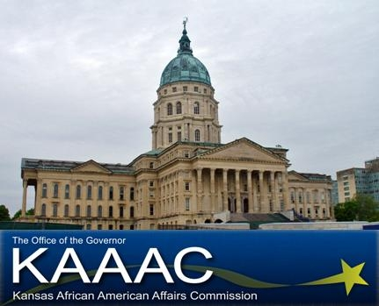
Application Form
DEADLINE FOR APPLICATION:
March 11

• Students must complete ALL information on pages 1 through 3 of this application.
• Please type or print with black ink.
• Mail the application to the address on the last page (page 3).
• Please see Fact Sheet for additional application instructions.

8. School Mailing Address:
Street: _______________________
City: __________________________
State: _________________________
Zip: ___________________________

9. School Telephone number: ( )

10. Date Graduation Expected:__________

11. Birth date: ____________

12. Age: ________

13. Email: _________________________________________

1. Student's Name:
First: ___________________________
Middle: ________________________
Last: ___________________________

2. Male____ Female____

3. Residence Address:
Street: _______________________
City: __________________________
State: _________________________
Zip: ___________________________

4. Mailing Address, if different than above:
Street: __________________________
City: ____________________________
State: ___________________________
Zip: ____________________________

5. Home Telephone number: ( )

6. Name of High School:

_______________________________________

7. Grade level on postmark date above: ________

13. School and Community Involvement
Below, please briefly list your involvement with your school and community. This may include any after school activities, club memberships, offices held, volunteer or work experiences.

School Activities:
Organization/Activity Dates Grade Level at the time

_________________________________________________________________________________________

_________________________________________________________________________________________

_________________________________________________________________________________________

_________________________________________________________________________________________

Community/Volunteer or Work Activities:
Name of Activity Dates Grade Level at the time

______________________________________________________________________________________________

_______________________________________________________________________________________________

______________________________________________________________________________________________

_______________________________________________________________________________________________

Please list your future Career or Job Interest(s):

14. State Senate Representative's Name:

15. State House Representative's Name:

16. Tell Us Your Story
To determine your readiness to participate in this leadership event, please respond to the questions below. You may submit your responses in a format of your choice (written essay, videotape, or audiotape). Your complete responses to these topics should not exceed two (2) typewritten, double-spaced pages, or five minutes of taped response.

- IMPACT – What African Americans contributions over the past 150 years have made a significant impact on your life? How do you plan to make a lasting contribution to the African American community?

(2) POSITIVE INFLUENCE - In terms of leadership, please tell us about two people who have positively influenced your life. Why? (Families, teachers, counselors, friends, public officials or celebrities are appropriate examples.)

17. Please use the checklist below to make certain your application packet is complete. All questions must be completely answered along with requested recommendation letters and other requested information.

Required Items | Enclosed
1. Application form (3 pages)
2. Written or taped response to two topics

__________________________________ ___________________
Signature of Student Date

Thank you for completing this application. If you have any questions, please contact the KAAAC office at 785.296.4874 or e-mail: shawn.bryant@ks.gov. Further information and a printable application can be found on the KAAAC facebook page at: www.facebook.com/kaaac

Please the completed application to:
Kansas African American Youth Day
Kansas African American Affairs Commission
900 SW Jackson Suite 101
Topeka, Kansas 66612
-OR-
Email the completed application to:
shawn.bryant@ks.gov

Application format used with permission from the Kansas Youth Empowerment Academy

